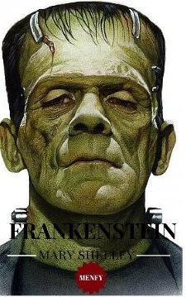
Wanted! New monster stars for “The New Frankenstein”.
Has your monster got what it takes?
Design and make a ‘monster’ for the film!
The monster must:
• be original and half-man, half-animal with 5 different characteristics or adjectives + 5 different functions
• be made from more than one fabric; precise its colour(s)
• use language (example of sentences or expressions)
• be suitable for a 5 year-old child
My monster’s name is: _________________________________. You will present and describe it in 10- 15 lines after making its identity card.

CF: Monsters of Greek Mythology (centaurs; sirens; cyclopes; Minotaur; etc)

