« But where is Mr Smith?

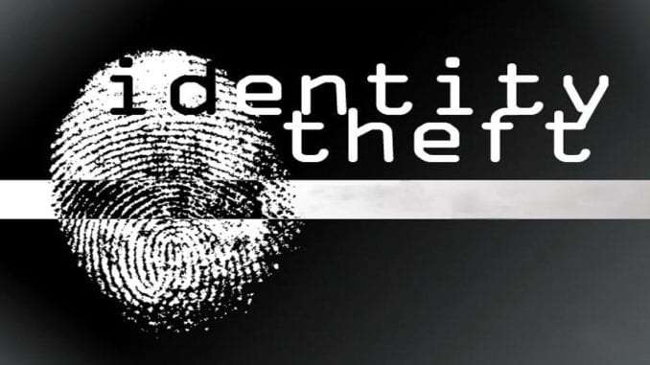

Theatre time : creative writing with « Sultan Bacchus »

Ecriture d’une piece de theatre en anglais en 1m.s.

Thème choisi en lien avec les métiers de la sécurité.

Janvier 2019 | théâtre en anglais | Olivier Bonnardot et Séverine Dumont.

**Intitulé du projet : « faire du théâtre en anglais : yes we can ! »**

**La famille Smith ayant déclaré la disparition du père de famille, les inspecteurs interrogent le seul témoin, l’homme de ménage et les suspects désignés par celui-ci.**

Scene 1 : les inspecteurs interrogent l’homme de ménage de la famille Smith pour savoir s’il a vu quelque chose ou quelqu’un

Inspector Brice and Inspector Hans question the cleaning man,Mr Peter Clean :

* + - Hello we are policemen
    - Hello Sirs
    - we are coming together for the murder of Lawrence Smith
    - Allright
    - we have some questions for you
    - ok
    - Where were you ?
    - Here in the hall
    - What were you doing ?
    - I was cleaning
    - Have you seen anyone ?
    - Yes I have
    - What was he/she like ?
    - I think it was a man

_ You must come with us to the police station to meet our suspects

_ OK I follow you

At the police station, showing him the suspects :

_ So , Mr Cleaning, who is it ?

_ it’s him, designing Penguin.

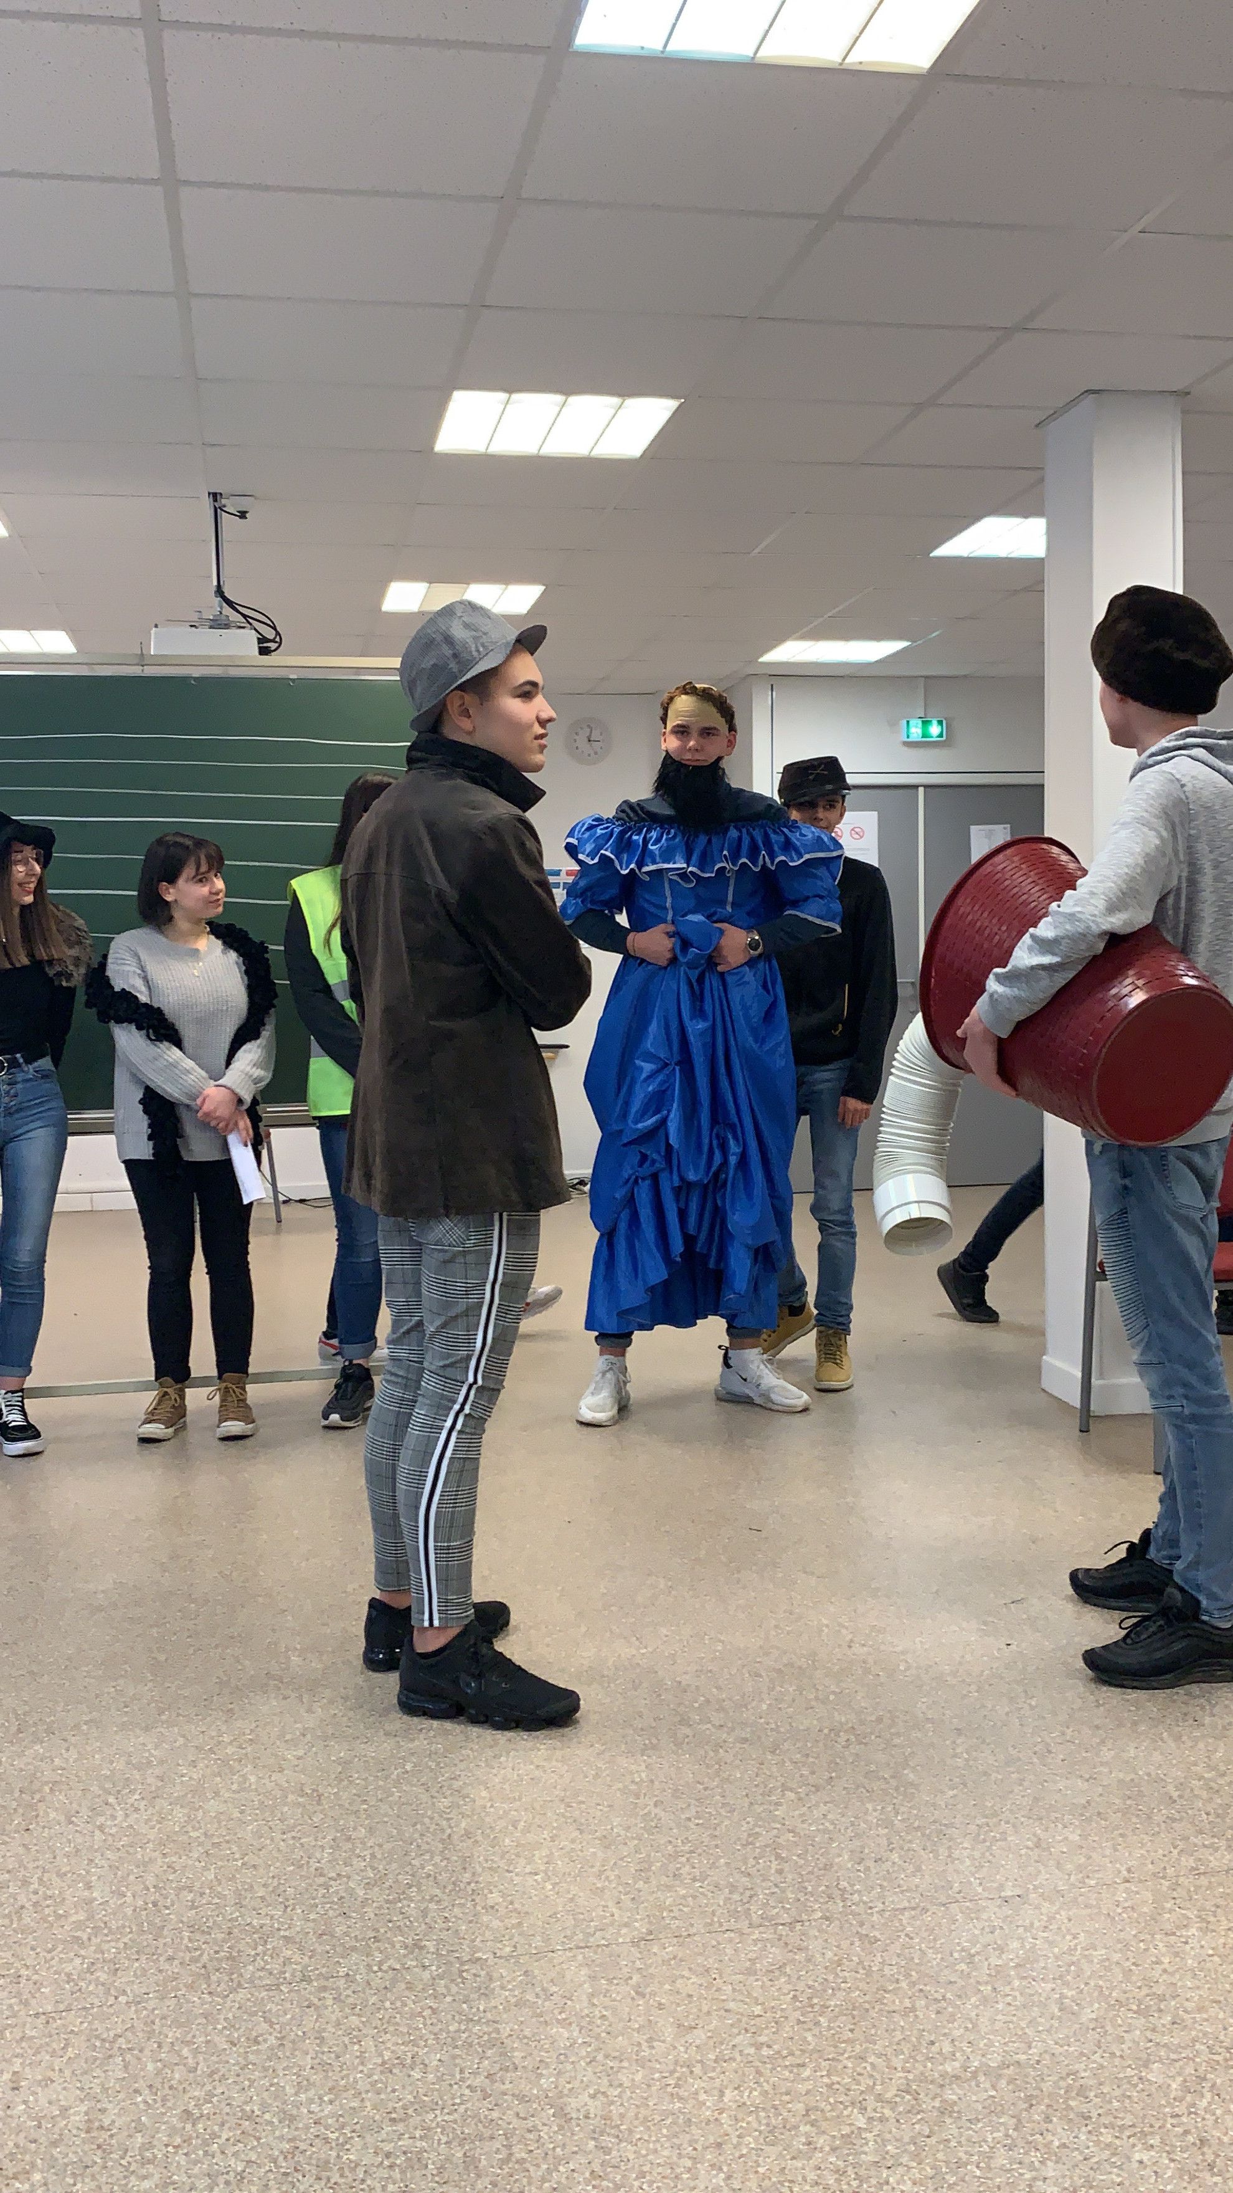

Scene 2 : Penguin’s interview by the inspectors

**Situation :**

We have to steal because we would like to have a party and we have no money. We’re going to steal the store that’s around the corner. We hope to be able to steal coke. We stole yesterday at 6 pm as JP distracted the security guard and PENGUIN stole at the same time. Then we escape on the motorcycle.

**Dialogue :**

* + - Hello Sir, what’s your name ?
    - Penguin
    - We have questions for you in relation to Lawrence Smith
    - I don’t know Mr Smith

What were you doing between 3 o'clock and 9 o'clock ?

* + - I was stealing in a shop
    - really ? for 6 hours ?
    - OH yes I was stealing because we have no money
    - do you think i'm stupid ?
    - No, Sir, I want to call JP
    - Who is he ?
    - My friend, with me in the shop

OK call your alibi

After giving him a phone :

_ Hello JP, I’m at the police station, Come on ! Come on ! It’s urgent

_ OH shit, I’m coming

* Arriving at the police station, JP is questioned:

_ Hello sirs

_ Hello, Sir, what were you doing between 3 o'clock and 9 o'clock

_ We were stealing in the shop

_ can you explain that to us ?

_ of course

* **Flash back : in the shop**

Lorie (the saleswoman)/ What are you hiding ?

JP/ OH ! It’s my baby

Penguin/ I’m fat

Lorie/ I call the security

JP/ Run Run !

Penguin/ Run ! 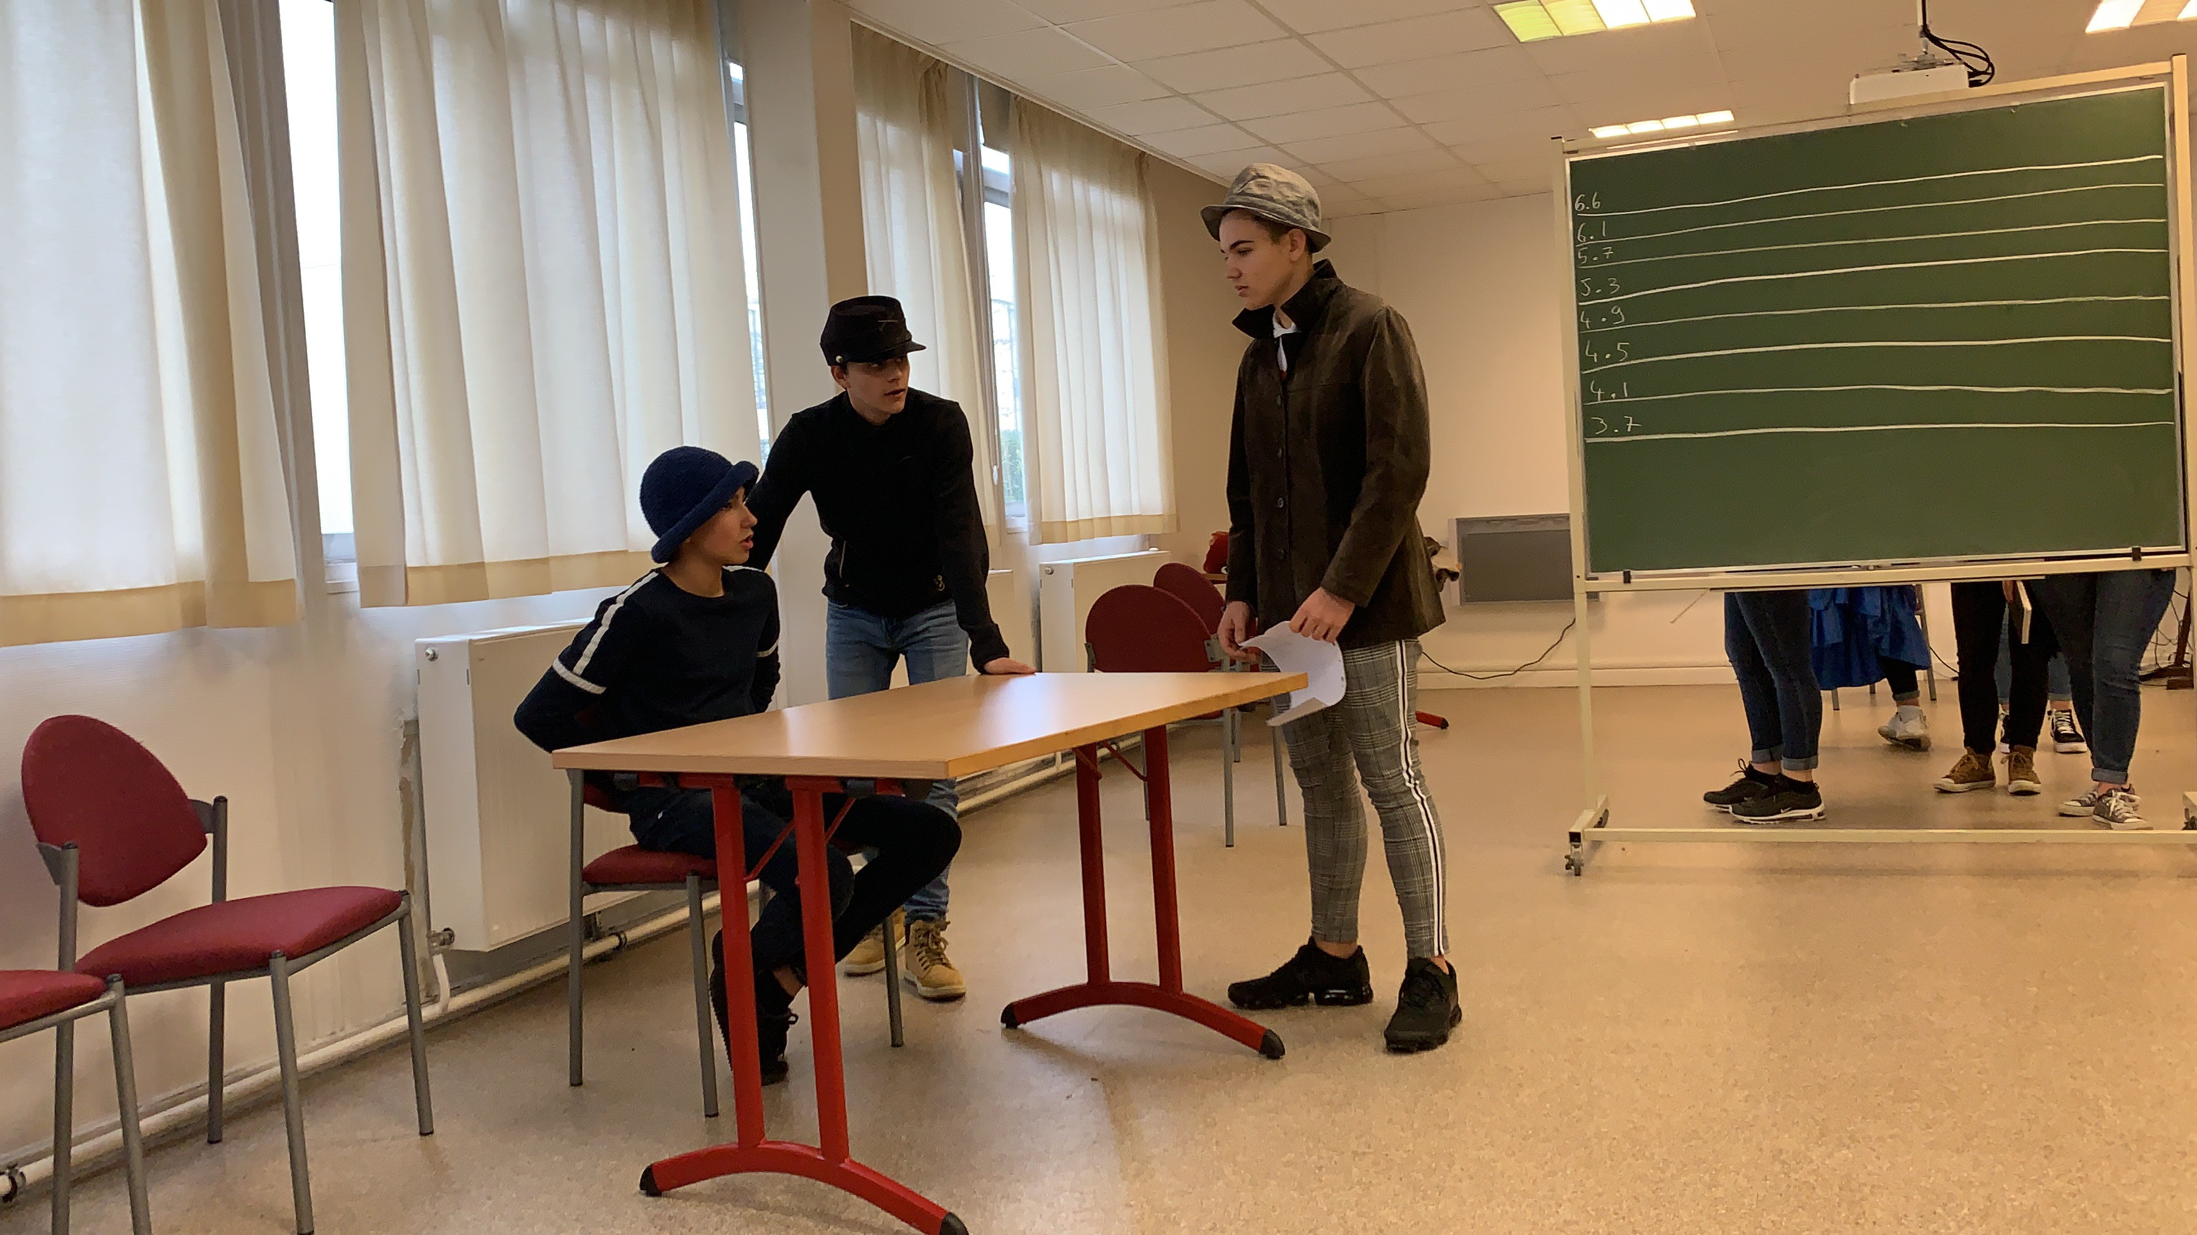

After JP’s story, the inspectors don’t believe Penguin is guilty because he has an alibi and yet arrest him for his crime : shoplifting !

After that, they call back the cleaning man and tell him the guy is not the culprit because he’s got an alibi. They ask him to design someone else from the suspects if he can and he indeed designates Nadège.

Scene 3 : Nadège’s interview by the inspectors

* + - Hello Miss, what’s your name ?
    - Nadege
    - We have questions for you in relation to Lawrence Smith
    - I don’t know Mr Smith

What were you doing between 3 o'clock and 9 o'clock ?

* + - I was in a car going back home
    - really ? for 6 hours ?
    - OH yes I was arrested by the police
    - do you think i'm stupid ?
    - No, Sir, I want to call Corinne
    - Who is he ?
    - My friend, with me in the car with me

OK call your alibi

* + After giving him a phone :

_ Hello Corinne, I’m at the police station and you must come

_ OK I’m coming

Once at the police station, Corinne is questioned by the investigators

_ Hello, Sir, are you Corinne ?

_ Yes I am

_ What were you doing between 3 o'clock and 9 o'clock ?

_ Well, I was with Nadege, I was driving being drunk and I was arrested by the police

_ Ok tell us the whole story.

**Flashback**

Nadège : Give me the steering wheel

Corinne : No I want to drive

Nadège : No, come on you’re drunk

Corrine : No, i’m competent to do this !

Nadège : I’m not sure Corinne

Corinne : Believe me!

Nadège : Hey ! The red light ! It’s so dangerous !

Corinne : Sorry, i haven’t seen it…

Nadège : You could drive with the lights on

Corinne : It’s a good idea !

Nadège : And drive slowly!

Corinne : Seriously ? It’s bad to drive at 50 kilometers per hour

Nadège : We could have an accident

Corinne : No, because i’m careful

Nadège : Oh! Look! the police are there !

Corinne : No, we will get away!

Nadège : No, no, no give me the steering wheel !

Husch (the police officer) : Put your car on the left

Husch : I need to see your driving licence

Husch : It’s not your licence

Corinne : Oh no! it’s the driving licence of my friend (Nadège)

Nadège : Yes, it’s my driving licence

Husch : You do not have your licence ?

Corinne : No, I don’t

Husch : So get out of the car, i’m going to do an alcohol test

Husch : Walk on the line

Husch : Stop! I arrest you because you’re drunk

Husch : Are you drunk Miss?

Nadège : No, I’m not drunk

Husch : So take the car

**After Corinne’s story, they turn to Nadege who asks them to believe them and check these information.**

_ Allright, let’s phone this police officer who arrested you.

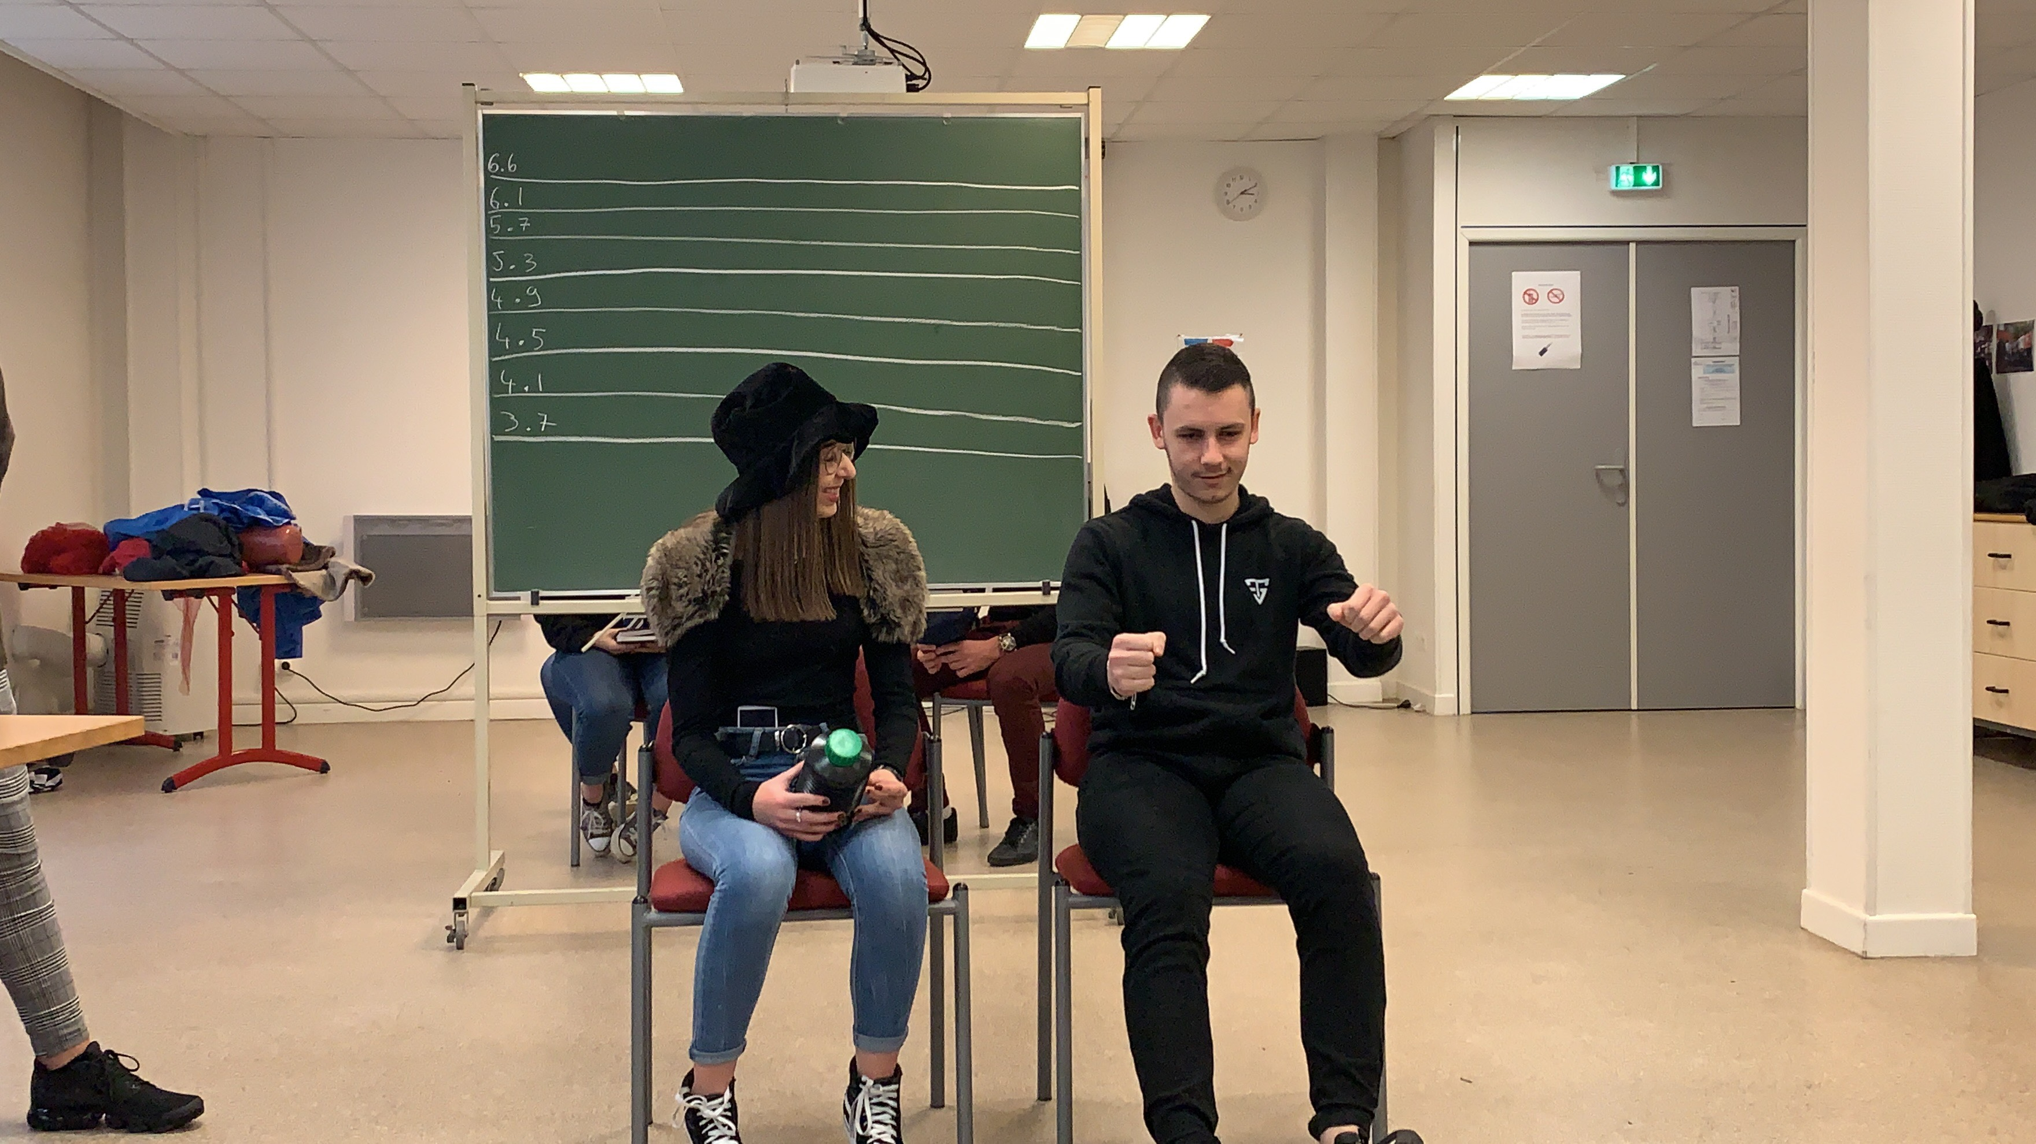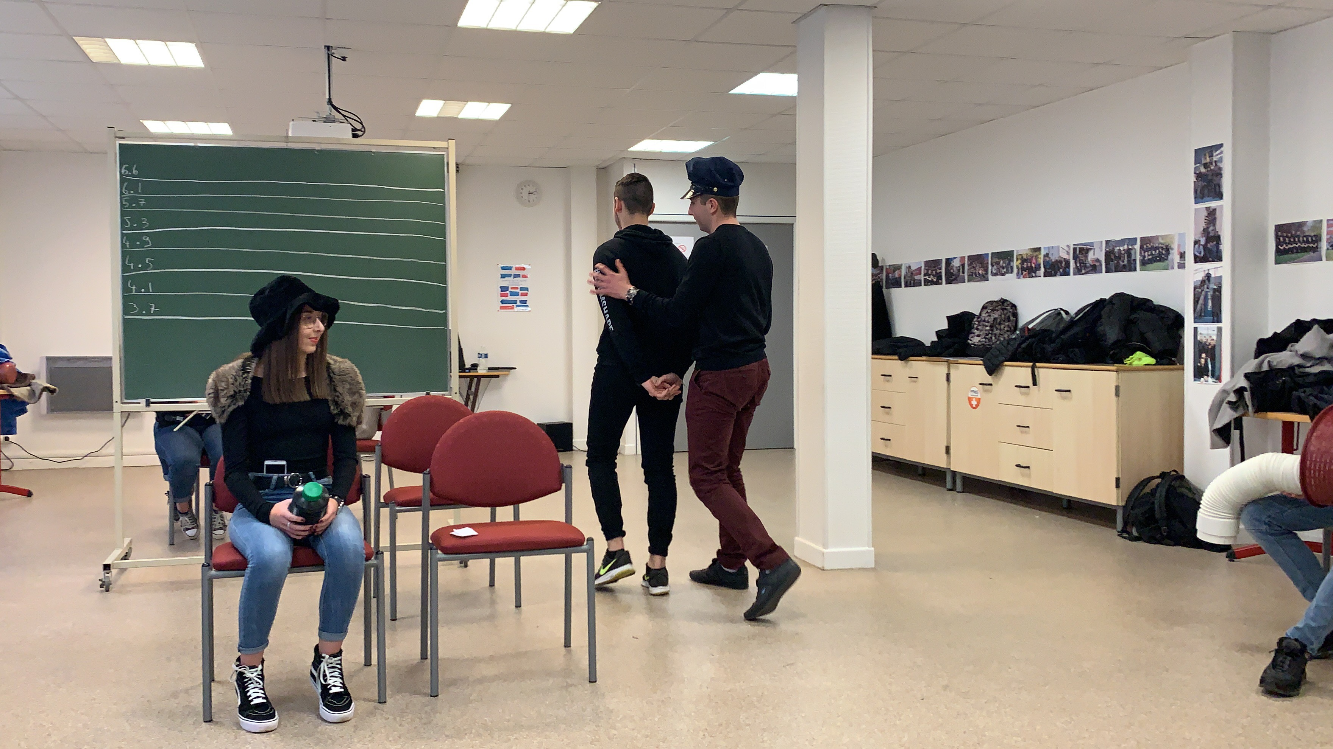

**After checking, they realise Nadege has an alibi and have to free her.**

**They are beginning to be irritated by the cleaning man’s statements.**

**They call him back, and tell him he was mistaken again. The cleaning man points at another suspect : Melany.**

**Scene 4 : Melany’s interview**

She tells the story of 2 teenagers on November 9th 2018.

They went to the Place de la République, in Dijon to demonstrate with yellow jerseys. The demonstration was ok, except for people breaking around and we were part of them. After we decided to burn cars.

**Then the inspectors accept she calls her alibi, Alice, and as they ask for more details, comes the flashback :**

* Let’s go to Place de la République, in Dijon to demonstrate
* Yes ! France must change !
* Shut up !
* Come on, go and burn the cars.
* No, we risk prison. It’s too dangerous for us.
* But no, come on.
* No ! shut up please !!!
* But yes, come ! They will see our anger and everything will change.
* The police will catch us.
* We go into a street and burn the cars !
* Ok ! but we throw the first flame and then we run away ; after that we go home directly.
* Thanks to us society will change !
* I hope so…
* Otherwise we’ll start again.

**Played by Sophie and Eva.**

**Once again the inspectors realise it’s a good alibi but theyu have to arrest them for burning a car !**

**As they call back the cleaning man, they are a bit nervous and would like him to be certain of his testimony. Mr Cleaning Peter then asserts the suspect is Zarinka.**

**Scene 5 : Darinka’s interview by the inspectors**

She says she went to the cinema with her friend Lionel and watched « The Nun » with pop-corn and soda. After the film they went to Mac Donald’s by car, and they took their drive thru. They ate in the car.

As they ask for more details, she asks to phone Lionel to come and tell them what he did.

*The flashback scene begins in the living room, in front of the television (the different channels are interpreted by Theo and Corentin J)*

Lionel : What are we doing ?

Derinka : I want to go to the cinema to watch « The Nun »

Lionel : what  film?

Darinka : “The Nun” ! I like scary movies.

*In the cinema*

Lionel : Do you want pop-corn and soda?

Darinka : Yes, I do

*Finished*

Darinka : That was so scary ! (Shocked)

Lionel : It was not scary. I even slept during the film

Darinka : Really ?

Lionel : Yeah…

I’m hungry, do you want to eat ?

Darinka : Yes, let’s go to McDonald’s

*In the car*

Lionel : Yes, but there are a lot of people, I prefer my cake

Darinka : What cake ? Do you cook?

Lionel : Yes, I do

Darinka : Can I try ?

Lionel : Of course let’s eat in the car

Darinka : Ok, because we haven’t enough time

I eat the cake and lose control of the car

Lionel : Laughs AH AH

Darinka : I feel so relaxed

Lionel : Oh that’s the police

Darinka : Oh it’s wonderful…

RATTAIRE David is Lionel (replaced) by JACKMIN Corentin

VOISINE Margot is Darinka

**Another mistake from the cleaning man. As Lionel was arrested by a policeman, Darinka’s alibi is true. They once again tell Mr Cleaning that he was wrong but he doesn’t understand where his error comes from and tries to convince his new suggestion is the right one ; he thinks he has recognized the suspect : Kenza ou Océane /Evan**

**Scene 6 :**

The flashback scene with the paparazzi

It’s in town in August. We saw Kanye West in a limousine with someone. We decided to follow him to his home. We took a photo of him with a woman. He was kissing her but it was not his wife. Afterwards, when he went out we asked him questions about his wife and if he doesn’t want to answer us, so we’ll show the photos to his wife.

1. Where were you ?

We were in town in August.

1. What did you see exactly ?

We saw Kanye West kiss a woman but it was not his wife.

1. What did you do there ?

We followed Kanye West.

1. What did you intend to do with these photos ?

We intended to blackmail him because he kissed another woman.

DIALOGUE with Kanye West :

Océane : Hello Kanye, we have questions for you.

Evan : Sorry, I’ve no time.

Kenza : We have good reasons to make you change your mind.

Evan : What do you mean ?

Océane : We saw you with another woman.

Evan : You have no proof.

Kenza : We have some photos.

Evan : What photos ?

Océane : Photos of you….

Evan : No problem.

Kenza : …With a lady…

Evan : What? give me the photos !!!

Océane : NO.

Evan : What do you want exactly ?

Kenza : We just want you to answer our questions.

Evan : OK.

Océane : Question number 1 : Which person would you have liked to be ?

Evan : I would have liked to be someone less known and not to be married to a well- known personality like KIM K.

Kenza : Question number 2 : what was your child’s dream ?

Evan : I wanted to be a firefighter.

Océane : Question number 3 : Do you plan to stop singing RAP music and give your children more time ?

Evan : It’s my project even if I like music. Can I have the photos?

Kenza : OK, But give us $1 million.

Evan : Do you want a cheque ?

Océane : NO ! Cash, please.

**Scene 7 :**

**Flashback at the restaurant**

B can I have a phone, please?

B Hallo

S Hallo

B Hallo

S Hallo

B Okay Sacha, can you come to the police station?

S No no no Babouch !

B No, you can’t do that to me!

S Sorry man…

B listen to me!

FLASHBACK

S Very Good restaurant

B I want to go to the toilets

B Oooh God! The Toilets are closed

S Go behind the bush

POOOOO

B You put laxative in my dinner

S No I didn't

B Why?

S Because you ate my dog's ears

B But I like it

BABOUCHE PUT SACHA IN THE POO

B Sorry man

S Sorry my friend

**During all that time spent in questioning their suspects, the inspectors could not imagine what happened in the Smith family.**

**Scene 8 : la famille Smith après les retrouvailles avec leur « père » revenu lors de l’anniversaire d’un de ses enfants.**

**« The Smith family »**

**Didier.** *Dad, can you give me salt please ?*

**Josh.** *No, I can’t my arm is aching*

**Aria.** *Oh, why ?*

**Didier.** *How did you do that ?*

**Josh.** *Do you remember when we fought together ?*

**Aria.** *Not at all, Dad ! It was during a rugby match.*

**Josh.** *Are you sure ?*

**Aria.** *Yes, sure !*

**Didier.** *Do you remember the last present you offered to Aria ?*

**Josh.** *A coconut perfume*

**Aria.** *No, not at all ! It was a concert ticket.*

**Josh.** *Oh……*

**Aria.** *And where is a cat ?*

**Josh.** *On the sofa, I think*

**Didier.** *No, dad, he’s dead !!!*

**Aria and Didier.** *Ok, we recognized you, uncle Josh !!!*

*(Maxime, Morgane, Corentin G )*

**Then the children call for the police that arrest Josh as he is not the father but the uncle. As Didier dials his father’s phone number, a sound comes from the vacuum cleaner…What a surprise to discover the phone and the body of their dead father…Uncle Josh killed him and got rid of him with the help of the cleaning man. This explains why he lied to the police concerning the suspects.**



**THE END**