The King

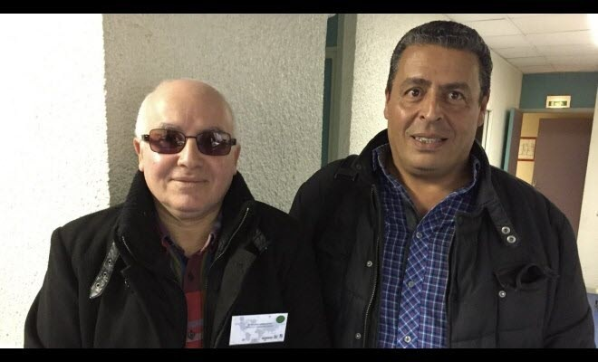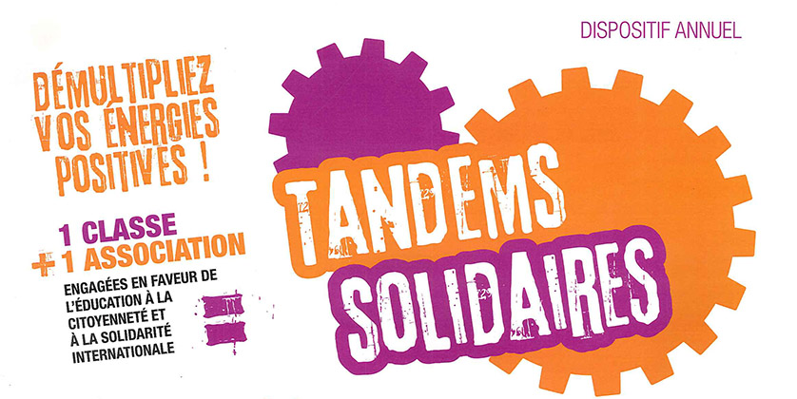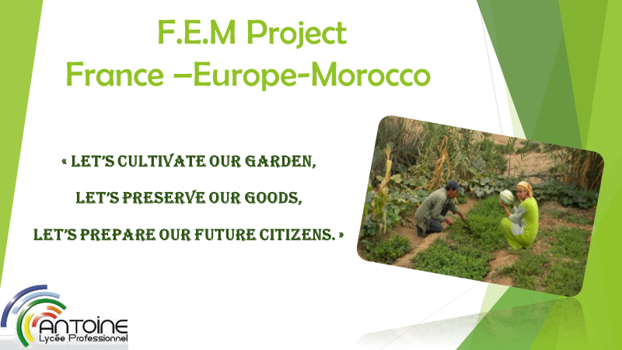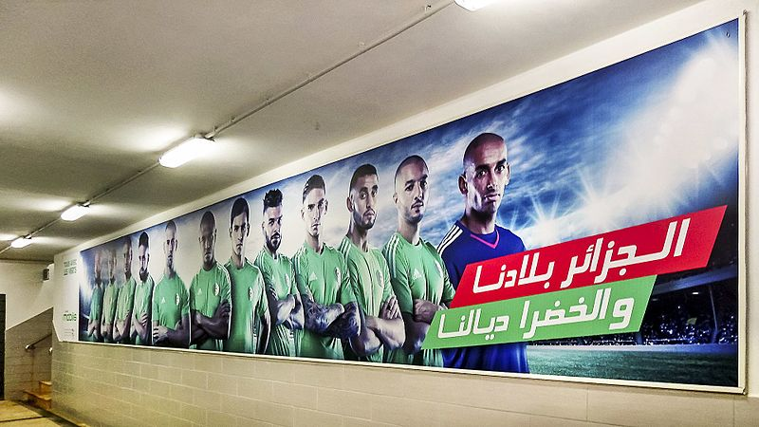

***Mr. Annachate and Mr. Abdel-Majid Rakho from La Boussole organization***

**PARTNERS :**

**LET’S GO TO MOROCCO!**

The 2PLP project with M.Idbazzi is to go to Morocco to install material into a school and to experiment a garden first behind the workshop.

On Wednesday 24th January we met Mr. Annachate and Mr. Abdel-Majid Rakho from La Boussole organization in our vocational school Antoine in the workshop from 2 p.m. to 5 p.m. During the first hour they presented the project. Then we presented the school, the professional fields and the workshop.

**Pupils’missions :**

MTITOU Amir : in charge of the garden and list of seeds

AISSAOUI Karim and a trainee in Master Com : in charge of the communication with Morocco (Demnate) for April 28th

DIALLO Amadou : in charge of the solar panels workshop

BENAHMED DAHO Saïd : in charge of the materials (finding and purchase)

Algeria qualified for the African Cup

2 Chenôve classes create new characters for *Charlie and the chocolate factory*

The best site to chat with foreign students

The project France  
Europe Morocco !