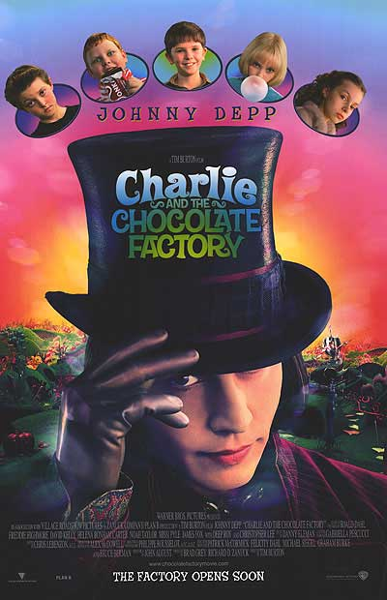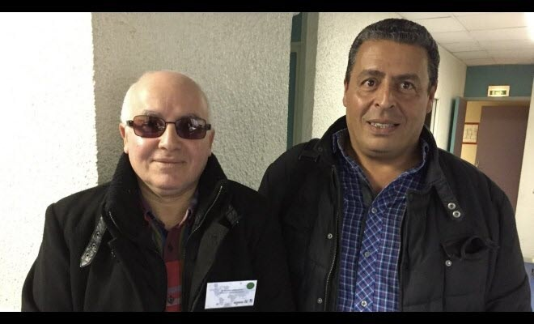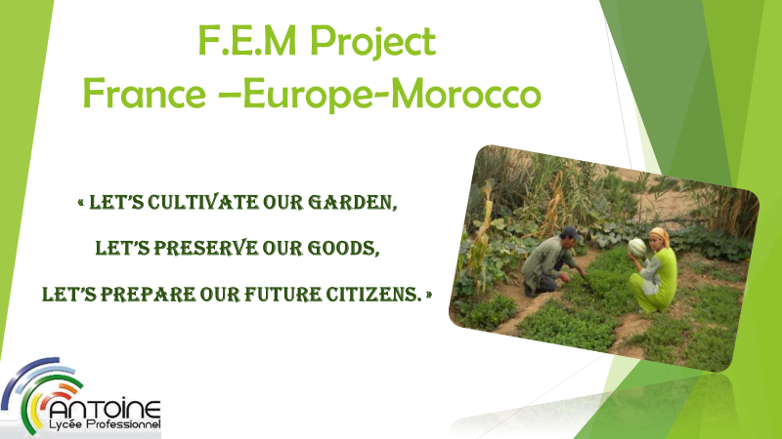

**New candies for Charlie and chocolate factory by the 2plp pupils**

Scenario: Tim Burton needs characters for a new version of his film:”Charlie and the Chocolate Factory”

Goal: New characters were made by Mrs Tietgen’s (3è) pupils from Le Chapitre(photo 1) and by a Turkish high school(photo 2). After a casting made by Mrs Dumont’s 2PLP pupils, only one will remain!

"The 2PLP invent an original candy for each character and write an accompanying commercial to advertise their product. They present their invention and commercial to the class. Finally as they have selected one character (from their partners’ creations), they write a letter to persuade Mr Wonka to manufacture only one and market it. Join your ad for your new candy. Afterwards they decide to eliminate the other characters during their visit in the factory.”

**The 2PLP project with M.Idbazzi is to go to Morocco to install material into a school and to experiment a garden first behind the workshop.**

On Wednesday 24th January we met Mr. Annachate and Mr. Abdel-Majid Rakho from La Boussole organization in our vocational school Antoine in the workshop from 2 p.m. to 5 p.m. During the first hour they presented the project. Then we presented the school, the professional fields and the workshop.

communication with Morocco (Demnate) for April 28th **;** Amadou Diallo will be in charge of the solar panels workshop **;** Said Benahmed will be in charge of the materials (finding and purchase).

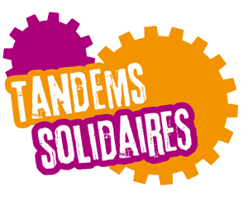

**Let’s go to Morocco**

**Pupils’missions**

Amir Mtitou will be in charge of the garden and list of seeds ; Karim Aissaoui and a trainee in Master Com will be in charge of the

*Mr. Annachate and Mr. Abdel-Majid Rakho from La Boussole organization*

Amir’s and Karim’s times